

**KABARAK UNIVERSITY**

**SCHOOL OF COMPUTER SCIENCE AND BIOINFORMATICS**

**DEPARTMENT OF COMPUTER SCIENCE AND IT**

**PROJECT DOCUMENTATION**

**PROJECT TITLE: FLOOD RESILIENCE APPLICATION**

**A project Report Documentation Submitted in the Department of Computer Science and IT in partial fulfillment of the degree of Computer Science**

**NAME: DORINE AKINYI**

**REGISTRATION NUMBER: INTE/MG/0661/09/20.**

**SUPERVISOR: MR. MOCHOGE**

**Submitted on: April 2024**

# **DECLARATION AND APPROVAL**.

I declare that this work is my own except where quoted and has not been submitted to this or any other university for examination.

Name: Dorine Akinyi

Reg No: INTE/MG/0661/09/20

Signature: ­­__________________ Date: ____________________

Under the supervision of:

Name: Mr. Cleophas Omanga Mochoge

Signature: __________________ Date: ______________________

# **DEDICATION**

I dedicate this project documentation to my family and friends for continuously supporting me throughout the research period.

# **ACKNOWLEGEMENT.**

I would like to thank the Almighty God for giving me good health throughout my project implantation and documentation. I would also like to thank my lecture Mr. Mochoge for the guidance that he gave me throughout these period.

# **ABSTRACT**

Flood destruction in Kenya has become a common problem experienced in some counties during the heavy rainfall season. This happens especially along the lake shores, for example, some parts of Turkana County and many other counties. Not knowing when it will occur has become a major challenge. When it happens, it results to the loss of lives, livestock, farm produce, houses and even it disrupts the education and work of students and parents respectively. It brings down the economy of the country to some extent, as the government will need to send aid to the affected areas which is always costly. The people affected always incur a massive loss and they have to start a fresh after the floods which is very costly especially for those with low income. Coming up with an artificial intelligence model that uses machine learning to learn patterns from previous weather forecasting records to predict the nature of the next flood, and what needs to be done in order to minimize the losses that are likely to occur will be greatly beneficial especially to the people living in such areas and the country as well. This will help them save lives and property from damages and also reduce the funds that the government give out for aid at such occurrences.

# TABLE OF CONTENT

Contents

**DECLARATION AND APPROVAL**. ii

**DEDICATION** iii

**ACKNOWLEGEMENT.** iv

**ABSTRACT** v

TABLE OF CONTENT vi

**CHAPTER ONE.** 1

**INTRODUCTION.** 1

**1.1 BACKGROUND OF THE STUDY.** 1

**1.2 PROBLEM STATEMENT.** 1

**1.3 OBJECTIVES** 1

**1.3.1 GENERAL OBJECTIVE.** 1

**1.3.2 SPECIFIC OBJECTIVES.** 2

**1.4 JUSTIFICATION** 2

**1.5 SCOPE/LIMITATIONS** 2

**CHAPTER TWO.** 3

**LITERATURE REVIEW.** 3

**2.1 Introduction.** 3

**2.2 To investigate on a model that will enable government plan early on how to handle the floods.** 3

**2.3 To design an application that will improve the accuracy and timeliness of flood prediction**. 4

**2.4 To implement a model that will enable the government communicate flood predictions effectively to affected communities.** 5

**2.5 Concept Map** 6

**CHAPTER THREE** 7

**INTRODUCTION.** 7

**3.1 Research Methodology.** 7

**3.2 Data Collection Method used.** 7

**3.2.1 Interviews.** 7

**3.2.2 Online survey.** 7

**3.4 Design diagrams.** 8

**3.4.1 Context Diagram.** 8

**3.4.2 DFD Diagram.** 8

**3.4.3 Use case diagram.** 9

**3.5 Research Ethics.** 9

**CHAPTER FOUR** 10

**INTRODUCTION** 10

**4.1. System Architecture.** 10

**4.2 Front End Development.** 10

**4.2.1 Front end development code extracts.** 11

**4.3 User interface design.** 12

**4.4 User interface module.** 13

**4.4.1 Registration Page** 13

**4.4.3 Flood prediction module.** 14

**4.4.2 Results.** 15

**4.5 Back end development** 16

**4.5.1 Data model.** 16

**4.5.1.1 Rainfall Dataset** 17

**4.5.1.2 River Level Dataset** 18

**4.5.1.3 Database Table** 18

**4.6 System testing.** 19

**4.7 Test evaluation and feedback.** 19

**4.8 Deployment Methods.** 20

CHAPTER FIVE. 20

**5.1 Conclusion** 20

**5.2 Future work.** 20

**i.** **REFERENCES.** 21

**APPENDICES.** 23

**I.WORK PLAN.** 23

**II. BUDGET** 24

**LIST OF FIGURES.**

Figure 1:CONCEPTMAP 6

Figure 2:CONCEPT DIAGRAM 8

Figure 3:DFD DIAGRAM 8

Figure 4:USE CASE DIAGRAM 9

# **CHAPTER ONE.**

# **INTRODUCTION.**

# **1.1 BACKGROUND OF THE STUDY.**

Flood occurrence has become a common phenomenon in Kenya during heavy rainfall. The most affected counties are those along the river and lake shores such as Turkana and Kisumu. Most residents living in these areas are always caught unaware by the floods as they do not know if the current season that they are experiencing will just be heavy rainfall or will it cause floods. These has resulted to loss of livestock, houses, and to extreme extent, people lose their lives or are separated when a family member is carried away by the floods. The students in the affected areas always gets their studies disrupted as some schools also flood or those that do not are used as shelter homes for those whose homes have been destroyed. Workers also find it difficult to go to work since the floods may be severe to an extent that the roads are also flooded and vehicles cannot use it. People and live stocks may also contact diseases, such as typhoid and cholera as they swim through the water trying to save their belongings that they can. The government also faced loses as they have to send aid to the people in the affected areas, as the resources that they use may exceed the one set aside for disaster management.

This has brought the need for this model which will make it easier to predict if floods will occur in a certain area and give the necessary mitigation strategies to minimize loses.

# **1.2 PROBLEM STATEMENT.**

Flood occurrence in rainy seasons is become a major issue mostly affecting people living along rivers and lakes, which arises the need to solve this issue in order to reduce loses experienced during these times.

# **1.3 OBJECTIVES**

# **1.3.1 GENERAL OBJECTIVE.**

To minimize losses that occur during those times.

# **1.3.2 SPECIFIC OBJECTIVES.**

1. To investigate on a model that will enable the government plan early on how to handle the floods.
2. To design an application that will improve the accuracy and timeliness of flood prediction.
3. To implement a model that will enable the government communicate flood predictions effectively to affected communities.

**1.4 JUSTIFICATION**.

There is a lot of anxiety during the heavy rainfall season as people are not sure on the areas that will be affected by floods. This is because there is no certain way of knowing that a certain area will experience floods on a certain month. This usually causes inconvenience to the residents in those areas as they may opt to move only for the floods not to affect their areas, or choose to stay and be affected by the floods if it occurs in their area. This study is going to help the residents know when to move and when to stay. It will also help the government prepare for mitigation strategies in advance.

# **1.5 SCOPE/LIMITATIONS**

The study is going to require data on historical flood events, real-time weather data, geophysical data and river and basin data. This data may not be available or be of high quality in all areas. Another limitation is that the people may not trust the AI model as artificial intelligence is still new to most people. Also the cost of training and deploying the model can be expensive.

# **CHAPTER TWO.**

# **LITERATURE REVIEW.**

# **2.1 Introduction.**

Floods are a result of overflow in river banks and can cause enormous damage to loss of life and property including crops and infrastructure. These are common phenomena and are costly natural disasters. Floods are short-lived events that can happen suddenly, sometimes with little or no warning. These chapter is all about researches done in the past and how they are related to my research.

# **2.2 To investigate on a model that will enable government plan early on how to handle the floods.**

Floods can occur at any time, but weather or climate patterns have a strong influence on when and where floods occur, Smith (2002). The land management practices in the upper catchments may also contribute to the enhancement of surface water run-off and flooding and an unplanned human occupation in the lowland can also enhance the damages due to flooding. Extreme climate events such as floods have adverse effects on all forms of life. The degree of the effects depends on the resistance and resilience of the affected communities. With inadequate preparation for the El Nino floods, national resources are overstretched in the response phase.

Periods of heavy rain have affected areas of Kenya since late October 2023, causing floods in areas of Mombasa and in the counties of Mandera, Marsabit, Meru, Samburu, Isiolo, Turkana and Busia, among others. Kenya Red Cross reported on 06 November that floods have affected a total of 15,264 households across the country and at least 15 people have lost their lives. Wide areas of crops have been damaged and hundreds of livestock have perished.

The costs imposed by floods on humans, societies and ecosystems can be subdivided into impact or damage costs or simply losses and subsequent risk reduction and adaptation costs (Meyer *et al.* [2013](https://www.tandfonline.com/doi/full/10.1080/02626667.2013.857411)). Conceptually, comparing costs of adaptation with damages before and after adaptation can help in assessing the economic efficiency of adaptation (Parry *et al*. [Citation2009](https://www.tandfonline.com/doi/full/10.1080/02626667.2013.857411)). Indirect impact costs arise due to the disruption of the flow of goods and services (and therefore economic activity) because of a disaster and are sometimes termed consequential or secondary impacts, as the losses typically flow from the direct impact of a climate event (ECLAC [Citation2003](https://www.tandfonline.com/doi/full/10.1080/02626667.2013.857411), World Bank [Citation2010](https://www.tandfonline.com/doi/full/10.1080/02626667.2013.857411)). Indirect damages may be caused by the direct damage to physical infrastructure or sources of livelihoods, or because reconstruction pulls resources away from production.

In order for the cost incurred during these time to reduce, the government needs to be informed early enough before the occurrence of floods, so that they can set aside the money needed during those times or plan on how to mitigate the problem before it occurs.

# **2.3 To design an application that will improve the accuracy and timeliness of flood prediction**.

Creating an application for enhancing flood prediction accuracy and timeliness involves leveraging technological advancements and scientific methodologies. Determination of flood depth involves the fusion of surface extent with elevation data (di Baldassarre et al., [2011](https://onlinelibrary.wiley.com/doi/10.1002/eco.2460#eco2460-bib-0041); Schumann et al., [2007](https://onlinelibrary.wiley.com/doi/10.1002/eco.2460#eco2460-bib-0177))

Traditional image classification algorithms such as pixel-based (Landuyt et al., [2017](https://onlinelibrary.wiley.com/doi/10.1002/eco.2460#eco2460-bib-0114)), object-based and hybrid have been widely used in understanding floods(Zhang et al., [2021](https://onlinelibrary.wiley.com/doi/10.1002/eco.2460#eco2460-bib-0222)). However, such algorithms are computationally costly, require manual tuning and generate inferior mapping quality (Jiang et al., [2021](https://onlinelibrary.wiley.com/doi/10.1002/eco.2460#eco2460-bib-0096)); hence, the emergence of modern data-driven ML analyses methods that include random forest (RF) (Breiman, [2001](https://onlinelibrary.wiley.com/doi/10.1002/eco.2460#eco2460-bib-0014)), support vector machine (SVM) (Dhara et al., [2020](https://onlinelibrary.wiley.com/doi/10.1002/eco.2460#eco2460-bib-0040)) and artificial neural network (ANN) (Dong et al., [2021](https://onlinelibrary.wiley.com/doi/10.1002/eco.2460#eco2460-bib-0044)).

ML, which has several advantages over traditional approaches, is being used more and more in flood prediction and management. ML models may be trained on past data including rainfall, river flow, and satellite images. These models can aid in early flood warning, enabling more efficient preparation and response. ML models can assess real-time data from sensors and satellite imagery to monitor floods in near real-time.This makes it possible to identify floods early and thus speed up responses. By examining data on variables like land use, geography, and infrastructure, ML models may be used to evaluate flood risk. This can assist in locating flood-prone locations and providing information to guide management decisions. ML models are used to evaluate flood damage by using satellite images and other data sources. This speeds up the damage assessment process and provides information for decision-making on relief and recovery activities.

Although traditional statistical methods and hydrological models have been utilized extensively for flood forecasting, they frequently fail to represent the intricate and nonlinear interactions present in flood dynamics. Researchers have looked at different strategies in response to this constraint, and Deep Learning, a subset of Artificial Intelligence has demonstrated remarkable possibilities. Convolutional neural networks (CNNs) [Chen,2021], recurrent neural networks (RNNs) [Chang,2020], and their variants are examples of deep learning models that can handle enormous amounts of data, recognize complex patterns, and generate precise predictions. Given the numerous factors involved, such as rainfall, river levels, soil moisture, and topographic characteristics, these models excel at managing high-dimensional and spatiotemporal data, which are crucial for flood forecasting.

# **2.4 To implement a model that will enable the government communicate flood predictions effectively to affected communities.**

Effective communication of flood predictions to affected communities involves considerations of accessibility, clarity, and timely dissemination of information. It is acknowledged that reporting on hydro-meteorological disasters has improved significantly because of a denser satellite network, the Internet and international media, whereas earthquakes were recorded globally from terrestrial stations (Peduzzi *et al*. [Citation2012](https://www.tandfonline.com/doi/full/10.1080/02626667.2013.857411)).

When the government report on occurance of floods to communities on time, they will be able to avoid major losses.  Media play a role, the news coverage is much better, worldwide, than in the past and tends to be focused on the negative side of things (Kundzewicz [Citation2011](https://www.tandfonline.com/doi/full/10.1080/02626667.2013.857411)). Some call it a “CNN effect.” Risk reduction activities reduce the hazard and the potential lossby affecting exposure and vulnerability. This therefore ensures that the residents of the affected communities are well informed beforehand, so that they can look for mitigation strategies before the disaster occurs.

# **2.5 Concept Map**

Flood resilience application

Accurate prediction of flood occurrence

Community preparedness

Effective communication and Timely Response

Figure 1:CONCEPTMAP

# **CHAPTER THREE**

# **INTRODUCTION.**

This chapter deals with the research methods that was adopted for the collection of data.

# **3.1 Research Methodology.**

The research employed a mixed-methods approach, combining both qualitative and quantitative methodologies.

# **3.2 Data Collection Method used.**

# **3.2.1 Interviews.**

I interviewed individuals in the affected areas to get more insight on their awareness and preparedness for floods, and how willing they are to adapt to AI based predicting model for floods.

# **3.2.2 Online survey.**

* I referred to some websites to gain insight on the topic which will give me an understanding on the communities’ awareness, preparedness, and response to flood warnings and incidents.
* I reviewed academic papers, government reports, and articles on flood occurrences, weather patterns, and AI-based predictive models for flood forecasting.
* The dataset was collected from kaggle on historical data on amount of rainfall and river level datasets.

# **3.4 Design diagrams.**

# **3.4.1 Context Diagram.**

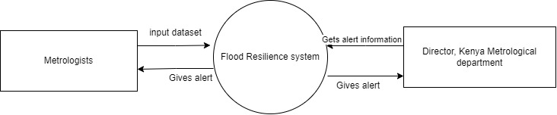

Figure 2:CONCEPT DIAGRAM

# **3.4.2 DFD Diagram.**

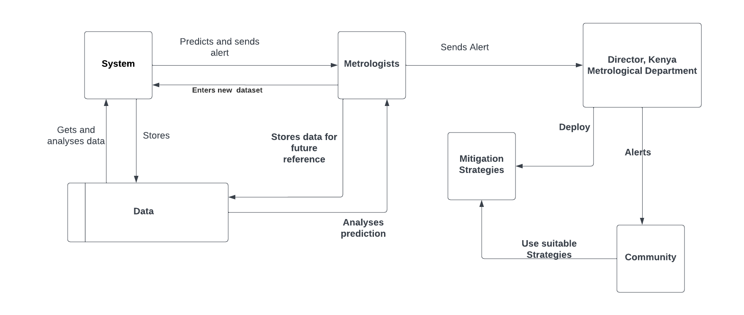

Figure 3:DFD DIAGRAM

# **3.4.3 Use case diagram.**

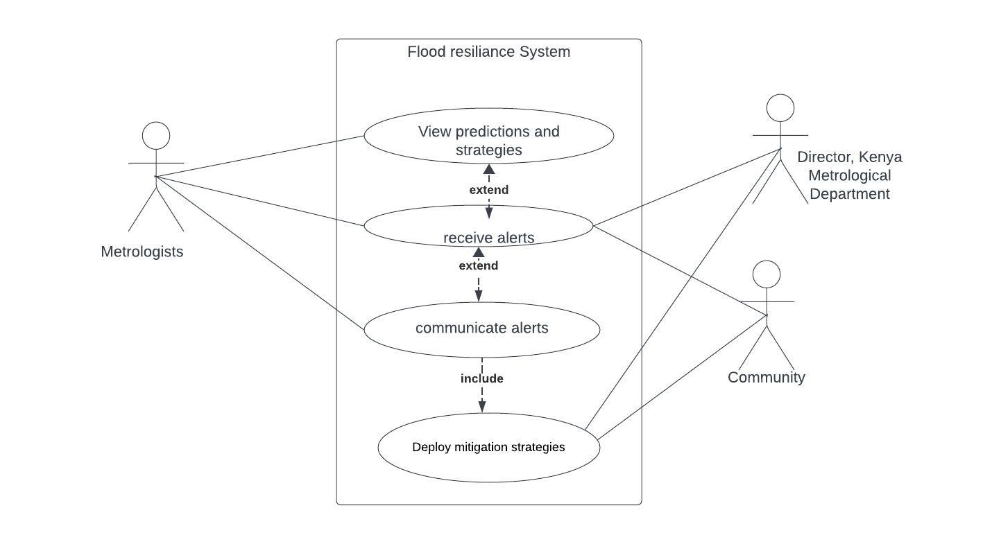

Figure 4:USE CASE DIAGRAM

# **3.5 Research Ethics.**

During the process of collecting data from individuals living in flood-prone areas, ethical practices were implemented such as, obtaining informed consent and ensuring confidentiality on the individuals who participated in the process.

# **CHAPTER FOUR**

# **INTRODUCTION**

The flood prediction model is an artificial intelligence and machine learning model that I developed to predict the occurrence of floods and help people to plan mitigation strategies in the case that floods occur.

# **4.1. System Architecture.**

The frontend of the system architecture consists of a user-friendly interface for users to interact with the flood prediction system. It allows users to enter the amount of rainfall which is used for prediction.

The data processing component uses linear regression to analyze the incoming data, extract relevant features and identify patterns that indicate the possibility of flood occurrence or the absence of floods. It also identifies the extent to which the floods are severe and provide mitigation strategies of the same.

# **4.2 Front End Development.**

In developing the front end, I used visual studio code which is a free platform. The language and framework I used are html and flask framework**.**

# **4.2.1 Front end development code extracts.**

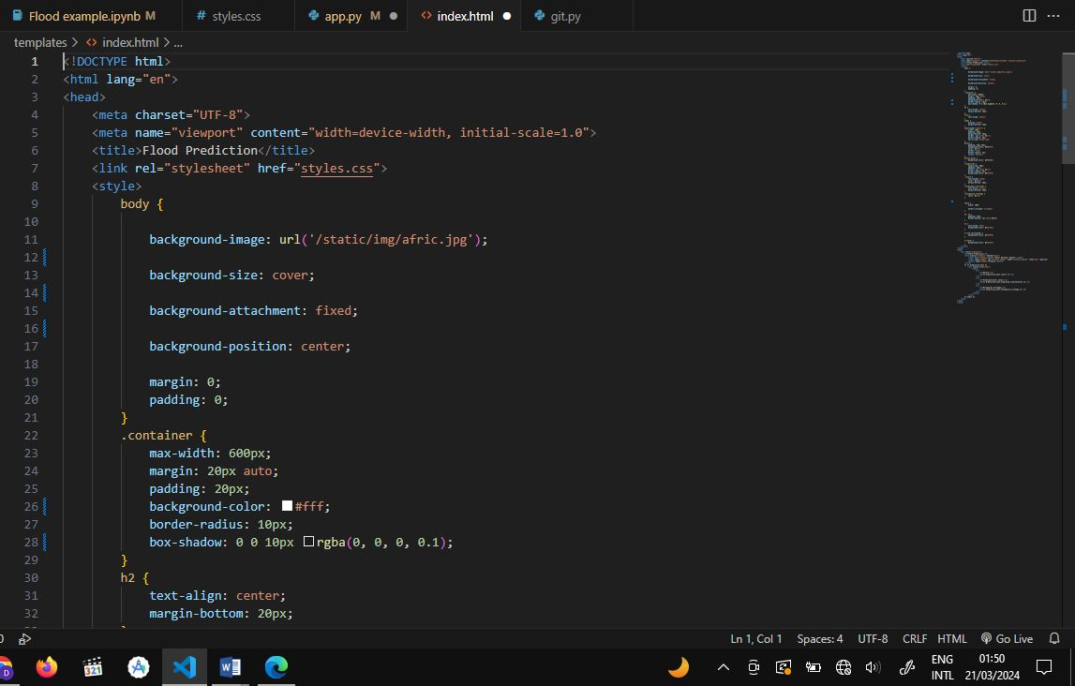

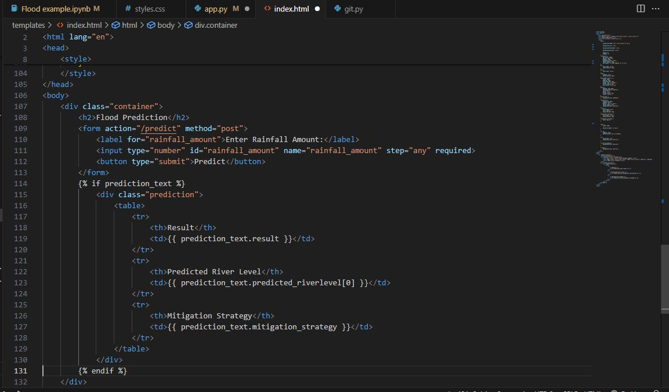

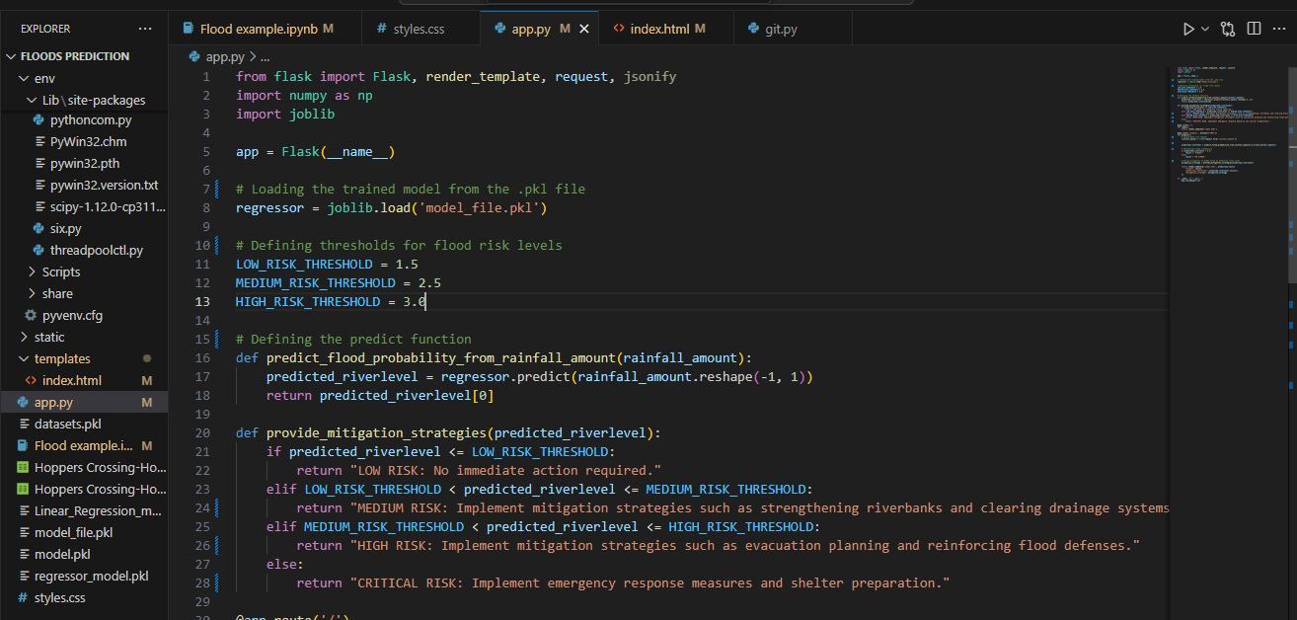

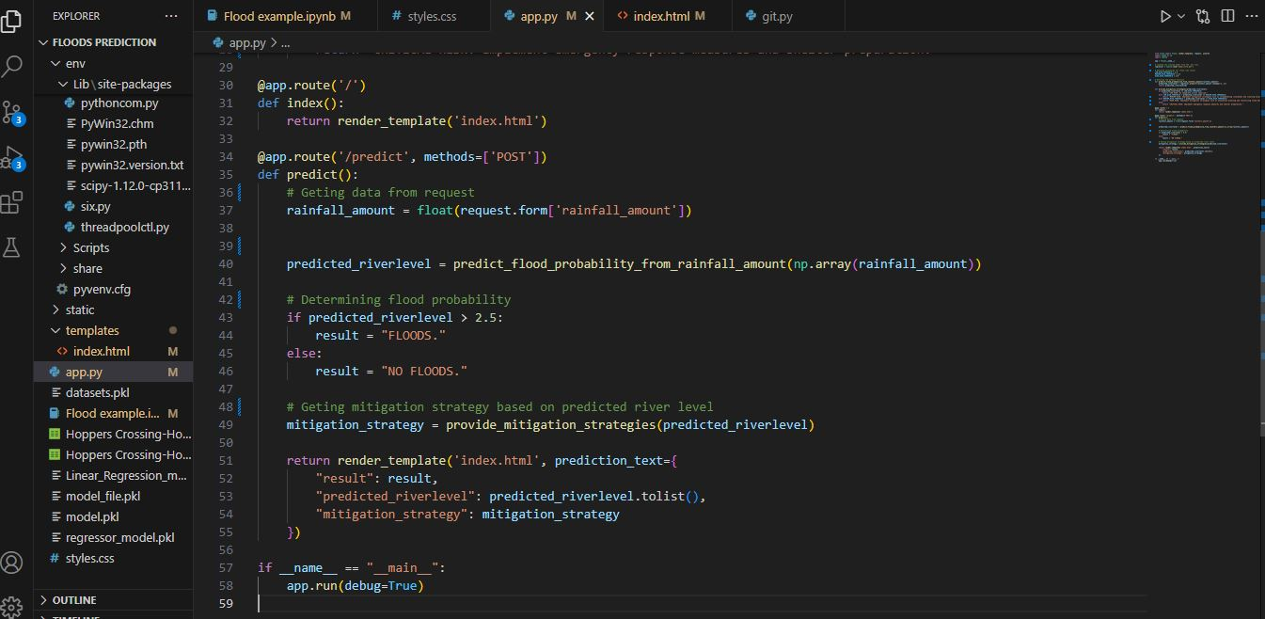

# **4.3 User interface design.**

I developed the user interface of this application using html, css and flask framework templates.

# **4.4 User interface module.**

# **4.4.1 Registration Page**

The user registers using their username, email and password. The data is then stored in the database.

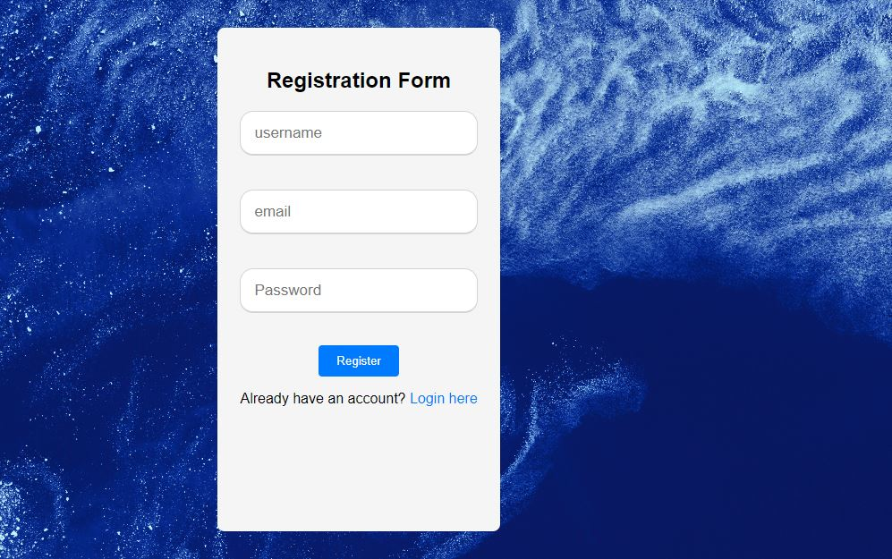

**4.4.2 Login Page.**

The user login using their username and password.

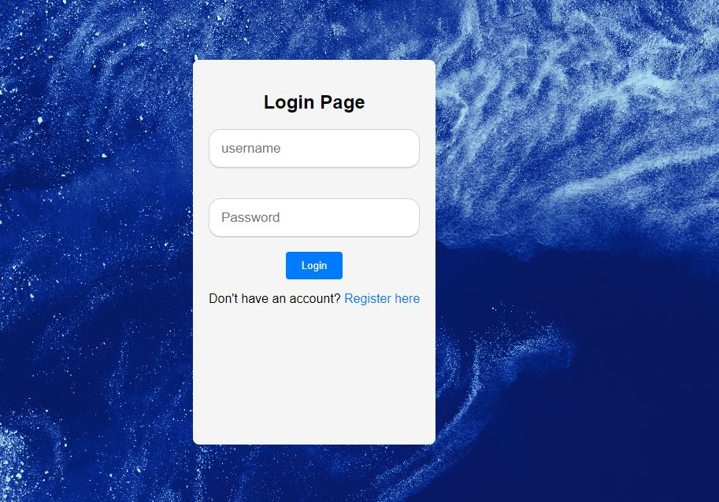

# 

# **4.4.3 Flood prediction module.**

The user enters the amount of rainfall.

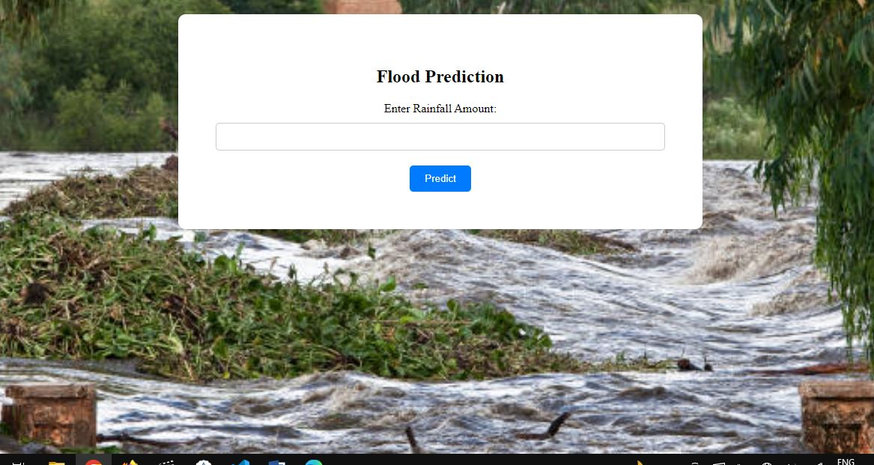

# 

# **4.4.2 Results.**

The application predicts the possibility of floods occurring and gives mitigation strategies.

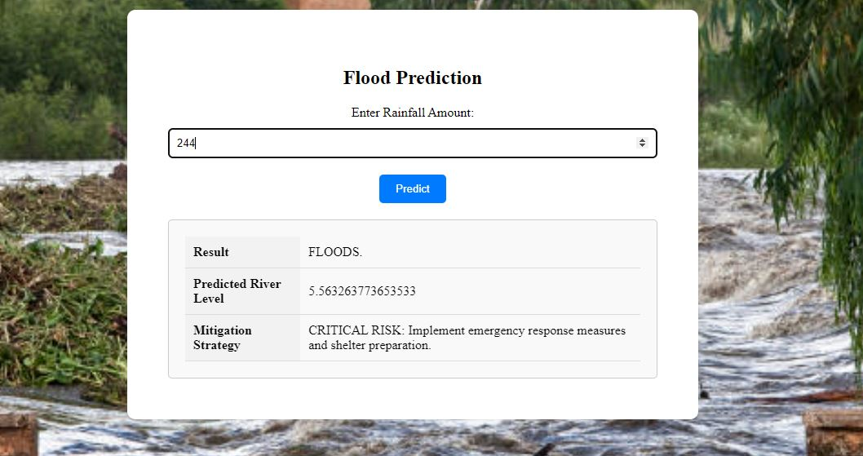

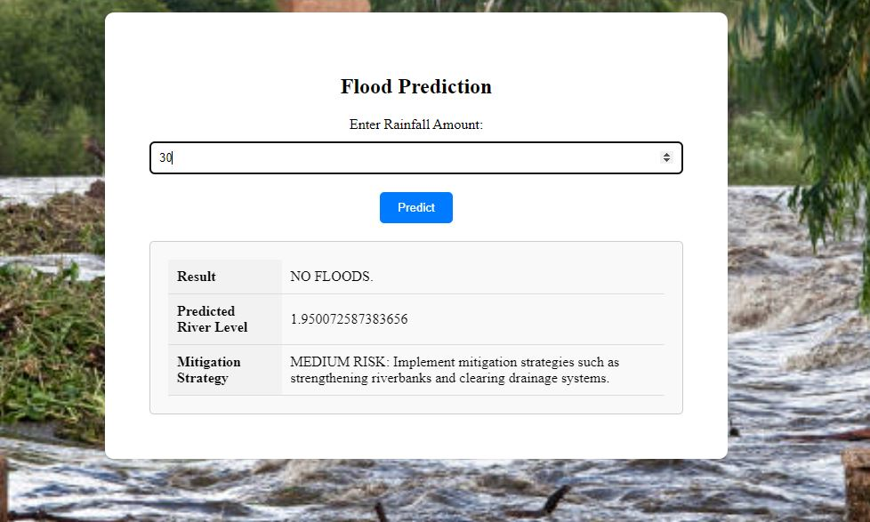

**4.5 Back end development.**

During the backend development phase, I used visual studio and excel to preprocess and manipulate the data before integrating it into the system. The process involved removing duplicates, removing null values and further preprocessing tasks. I also used MySQL database which provided a user-friendly graphical interface for database administration tasks.

# **4.5.1 Data model.**

The dataset consisted of the amount of rainfall and river level, which were stored separately in csv files.

# **4.5.1.1 Rainfall Dataset**

It has 78848 rows and three columns

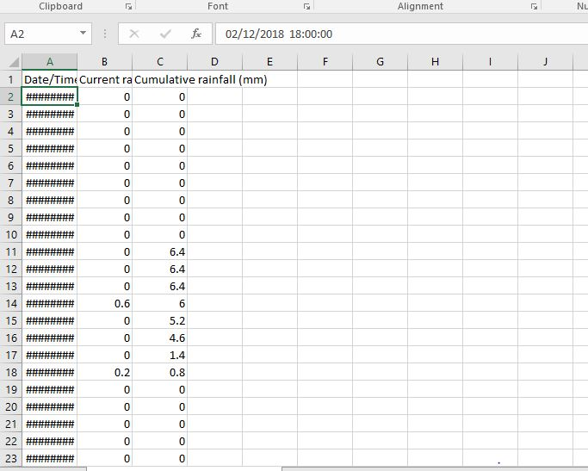

# **4.5.1.2 River Level Dataset**

It has 78822 rows and two columns.

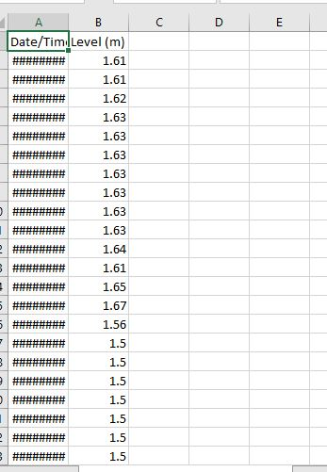

# **4.5.1.3 Database Table**

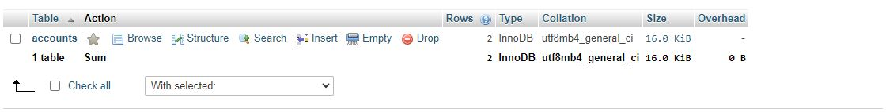

It stores information about who can access the system.

# **4.6 System testing.**

The test plan involves checking if the system is running efficiently and also to make sure the systems objectives were met. The table below show the different test scenarios carried out. It helps to identify the errors in the system and correct them.

|  |  |  |  |  |  |  |  |
| --- | --- | --- | --- | --- | --- | --- | --- |
| Test no. | Action | Input | Expected output | Actual output | Test browser | Test results | Test comments |
| 1 | Launch application | http://127.0.0.1:5000 | Login page | Login page | chrome | pass | Launch successful |
| 2 | Register with unique credentials | Username:  Email:  Password: | Registered  successfully | Registered successfully | chrome | Pass | Success |
| 3 | Registering with existing account | Username:  Email:  Password: | Account already exist | Account already exist | chrome | pass | Success |
| 4 | Login before registering | Username:  Password: | Invalid username/  Password | Invalid username/password | chrome | pass | Success |
| 5 | Login with correct credentials | Username:  Password: | Flood prediction page | Flood prediction page | chrome | pass | Success |

# **4.7 Test evaluation and feedback.**

No major bugs were experienced during the testing of the application. Users are allowed to make recommendations and suggestions for the purpose of making the system more useful, user friendly and making the system better in general.

# **4.8 Deployment Methods.**

I deployed my application on the website using flask web framework.

# 

# **CHAPTER FIVE.**

# **5.1 Conclusion**

The system predicts occurrence of floods and provides mitigation strategies according to the nature of the floods. This enables people to plan early, in preparation for floods in order to prevent and minimize losses.

# **5.2 Recommendations.**

The application was released with not so many functionalities due to the time limitations though the main objective of the system was achieved. The bright side of the system is that more functionalities could be added in the future as people present different ideas to add more functionalities to the application as well as to make it better.

# **REFERENCES.**

*Breiman, L. (2001). Random forests. Machine Learning, 45(1), 5-32.*

*Dhara, C., Das, A., & Kundu, M. K. (2020). Assessment of flood inundation hazard using machine learning techniques and a comparative study of random forest, support vector machine, and artificial neural network. Modeling Earth Systems and Environment, 6(4), 2671-2686.*

*Chen, J., Zhang, M., Ma, X., & Zhang, J. (2021). Flood depth estimation using convolutional neural networks with synthetic aperture radar data. Remote Sensing, 13(8), 1478.*

*Chang,. (2020). Flood depth prediction using recurrent neural networks and LSTM networks. Water, 12(2), 570.*

*di Baldassarre et al,. (2011). Flood-plain mapping: A critical discussion of deterministic and probabilistic approaches.*

*Dong, J. (2021). Comparison of machine learning models for flood inundation mapping using multi-temporal SAR images. Remote Sensing, 13(17), 3363.*

*ECLAC. (2003). Impact of natural disasters on the macroeconomic and fiscal sectors in the Caribbean: a decade of disasters (1990-2000). ECLAC sub regional headquarters for the Caribbean.*

*Jiang, Y., Wang, X., Xie, P., & Zhao, X. (2021). Flood mapping based on multi-source remote sensing data and random forest algorithm. Remote Sensing, 13(6), 1143.*

*Landuyt, T., Jacobs, L., Dondeyne, S., & Duchateau, R. (2017). Flood extent mapping using change detection and a hybrid pixel-based and object-based approach. ISPRS International Journal of Geo-Information, 6(3), 65.*

*Meyer, V., Becker, N., Markantonis, V., Schwarze, R., Van Den Bergh, J. C., Bouwer, L. M., ... & Vliet, A. V. (2013). Review article: Assessing the costs of natural hazards-state of the art and knowledge gaps. Natural Hazards and Earth System Sciences, 13(5), 1351-1373.*

*Parry, M. L., Rosenzweig, C., & Livermore, M. T. (2009). Climate change, global food supply and risk of hunger. Philosophical Transactions of the Royal Society B: Biological Sciences, 360(1463), 2125-2138.*

*Peduzzi, P., Dao, H., Herold, C., & Mouton, F. (2012). Assessing global exposure and vulnerability towards natural hazards: the Disaster Risk Index. Natural Hazards and Earth System Sciences, 11(6), 1737-1752.*

*Smith, J. K. (2002). Climate change and the impact of extreme events on the United States: the potential consequences of climate variability and change. Cambridge University Press.*

*World Bank. (2010). The costs of adaptation to climate change: evidence from the US coastal areas. The World Bank.*

# 

# **APPENDICES.**

# **I.WORK PLAN.**

|  |  |  |  |  |  |  |  |
| --- | --- | --- | --- | --- | --- | --- | --- |
| **ACTIVITY** | **SEPT** | **OCT** | **NOV** | **JAN** | **FEB** | **MARCH** | |
| Selection of topic |  |  |  |  |  |  | |
| Background of the study |  |  |  |  |  |  | |
| Literature review |  |  |  |  |  |  | |
| Research Methodology |  |  |  |  |  |  | |
| Correction of errors |  |  |  |  |  |  | |
| Finishing proposal |  |  |  |  |  |  | |
| System implementation |  |  |  |  |  |  |  |
| Documentation |  |  |  |  |  |  | |
| Project Presentation |  |  |  |  |  |  | |

**Table 1: Work plan**

**II. BUDGET**

|  |  |  |  |
| --- | --- | --- | --- |
| **Item** | **Description** | **Quantity** | **Cost** |
| Laptop | Hp revolve | **1** | **Ksh 60,000** |
| Printing |  | **1** | **Ksh 500** |
| Internet | Safaricom | **1** | **Ksh 5000** |
| Binding |  | **1** | **Ksh 200** |
| Integrated Development environment(IDE) | Visual studio code | **1** | **Free(open source)** |
| Database management | MySQL | **1** | **Free(open source)** |
| **Total** |  |  | **Ksh 65,700** |

**Table 2: Budget**